Test # | Description | PASS/FAIL
1 | Circle | PASS
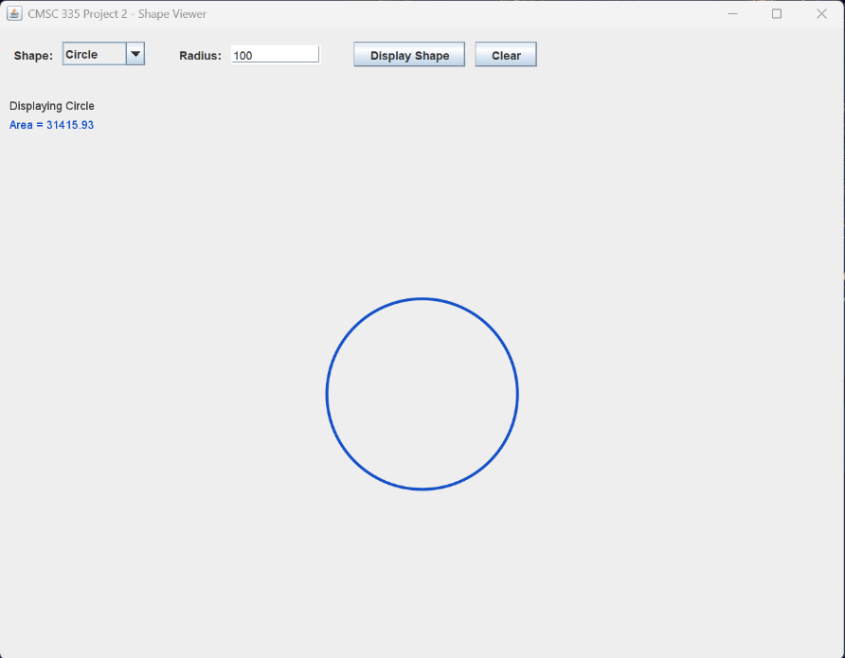
Test # | Description | PASS/FAIL
2 | Square | PASS
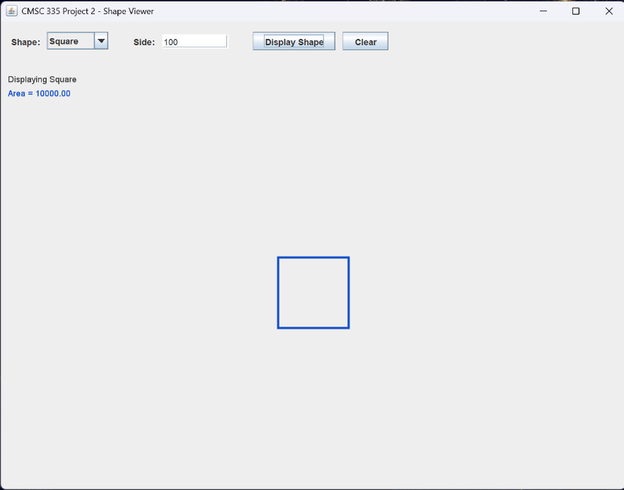

Test # | Description | PASS/FAIL
3 | Rectangle | PASS
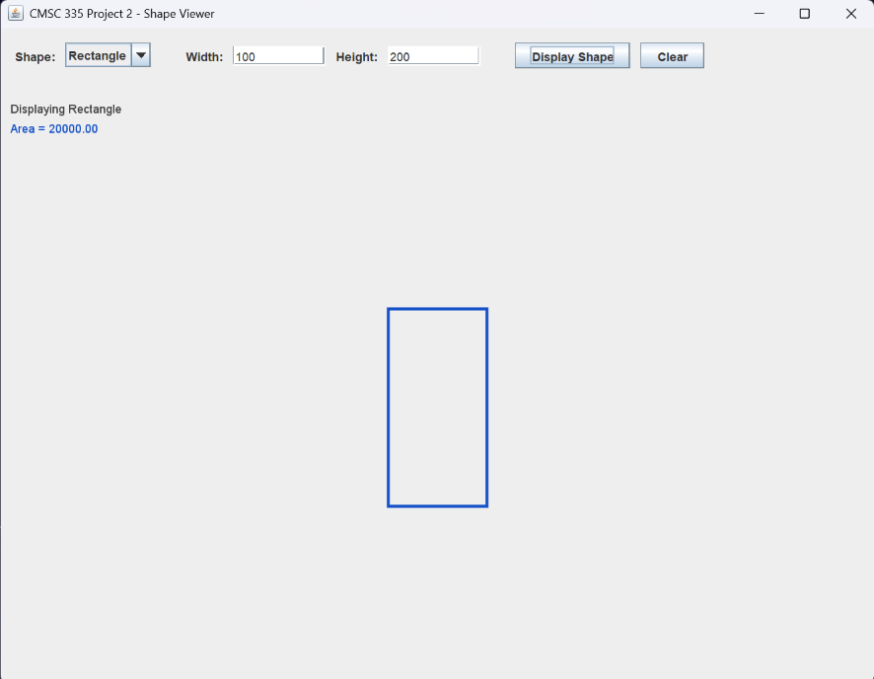
Test # | Description | PASS/FAIL
4 | Triangle | PASS
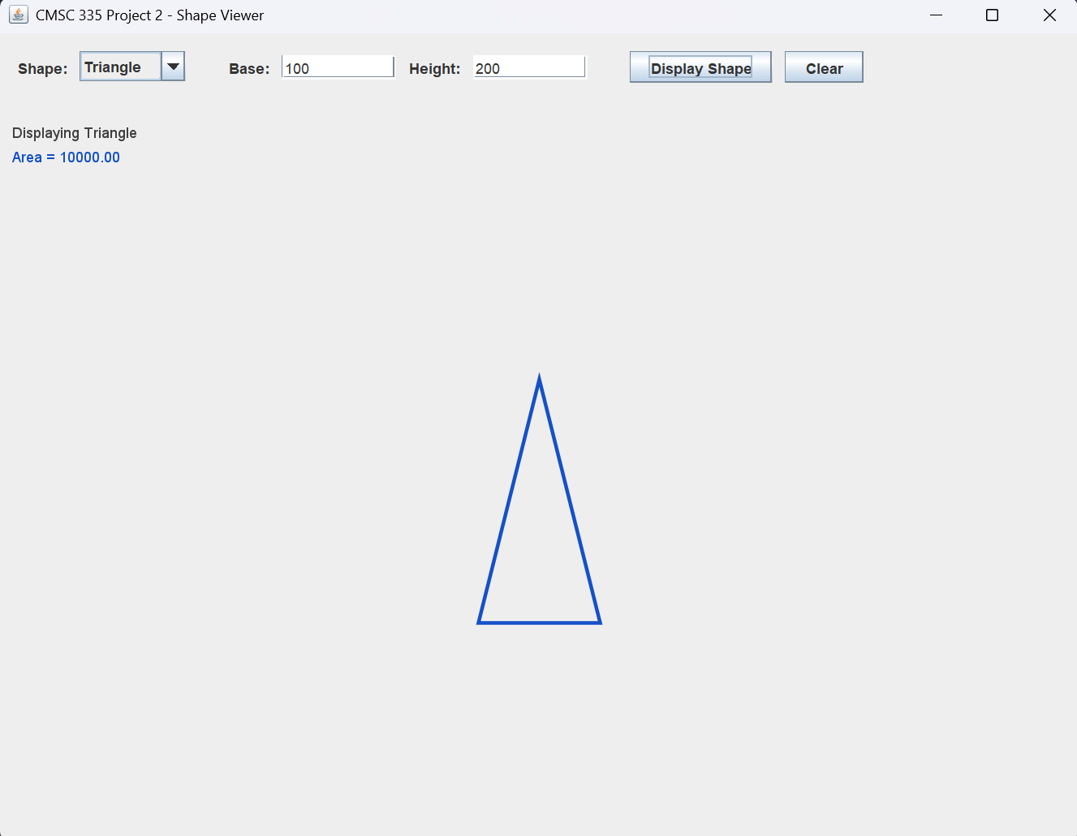
Test # | Description | PASS/FAIL
5 | Sphere | PASS
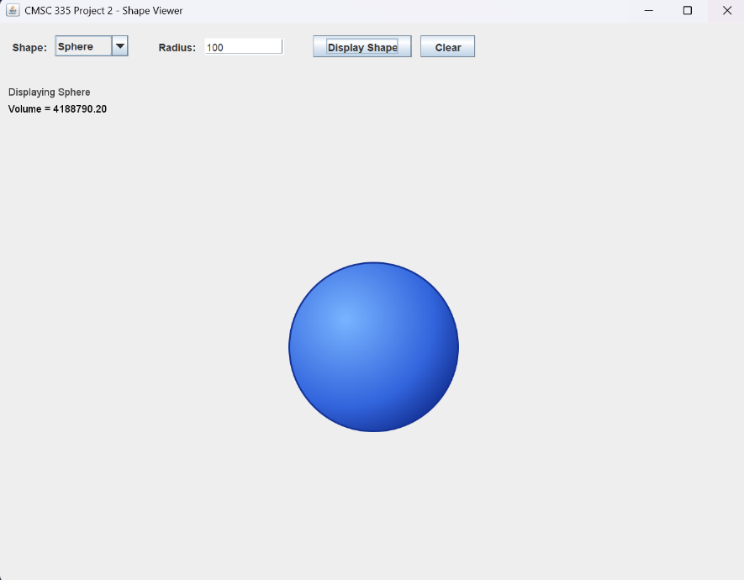
Test # | Description | PASS/FAIL
6 | Cube | PASS
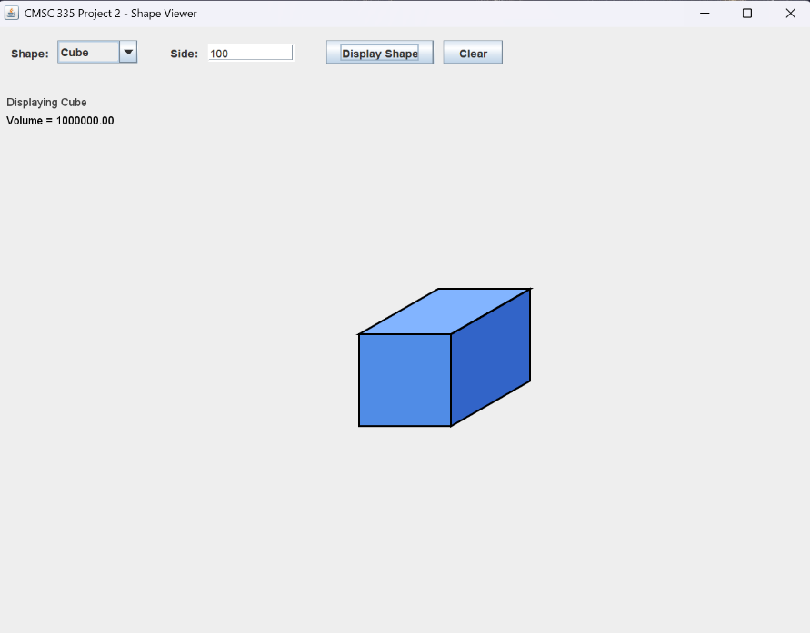
Test # | Description | PASS/FAIL
7 | Cylinder | PASS
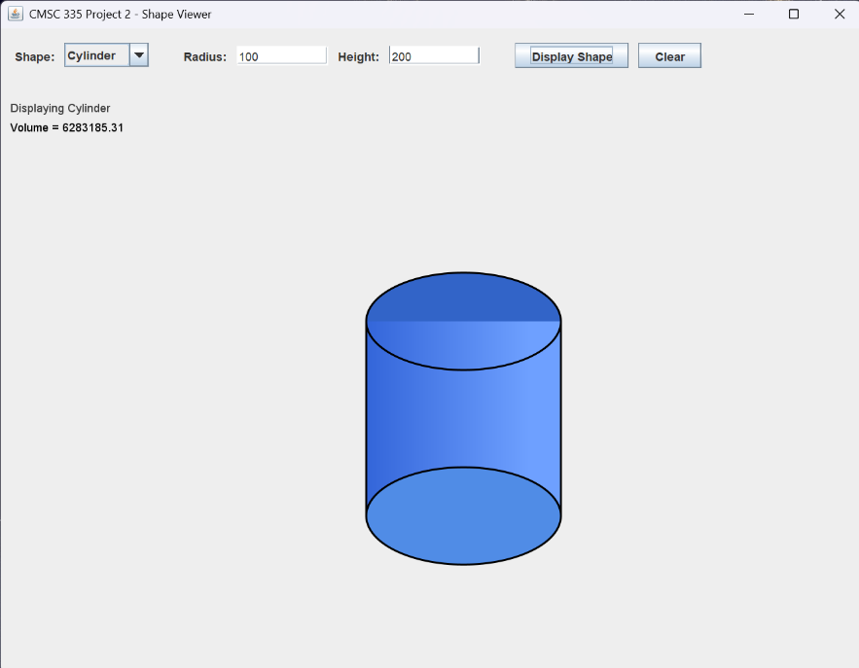
Test # | Description | PASS/FAIL
8 | Cone | PASS
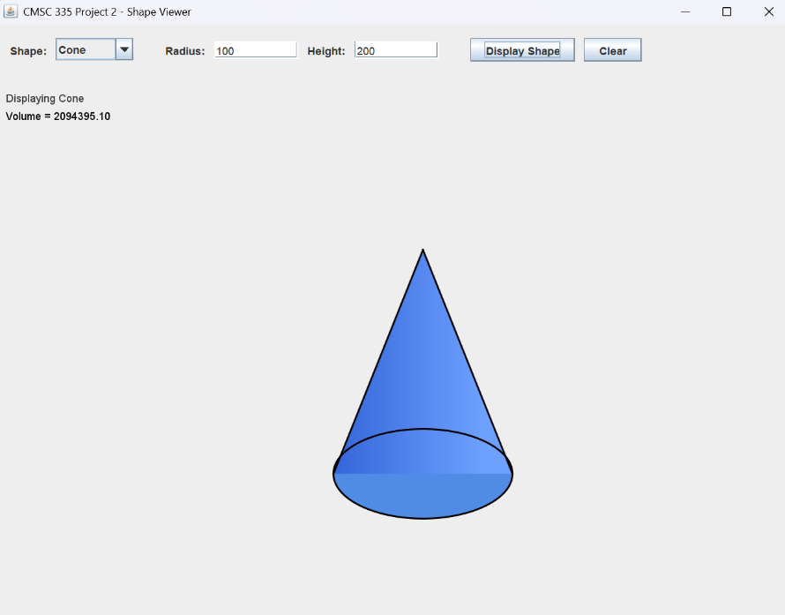
Test # | Description | PASS/FAIL
9 | Torus | PASS
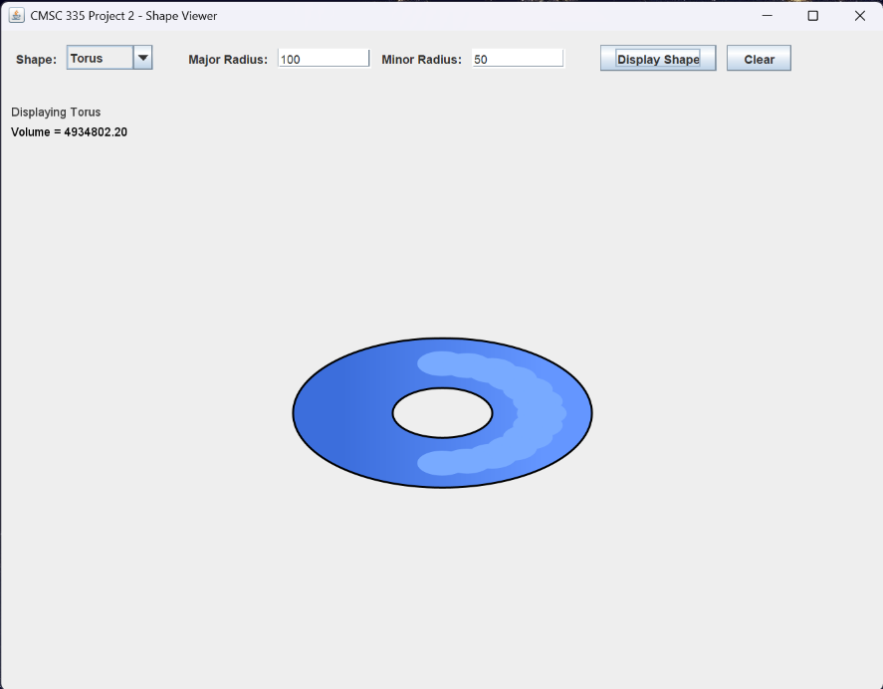
Test # | Description | PASS/FAIL
10 | Empty Field | PASS
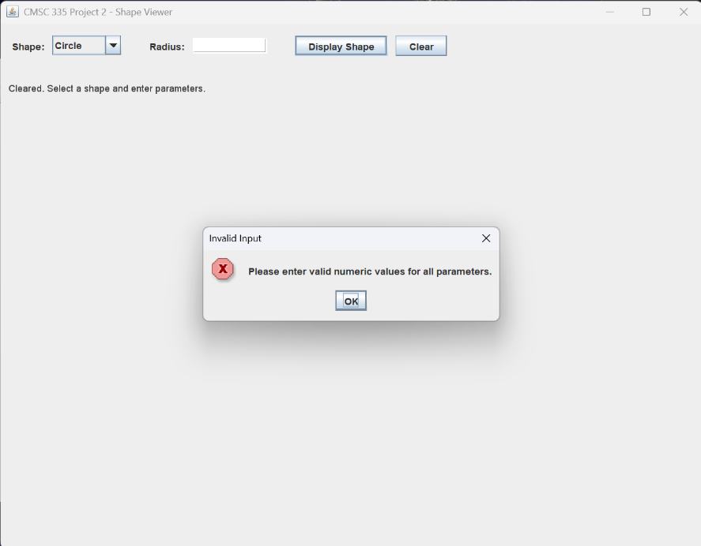
Test # | Description | PASS/FAIL
11 | Negative Value | PASS
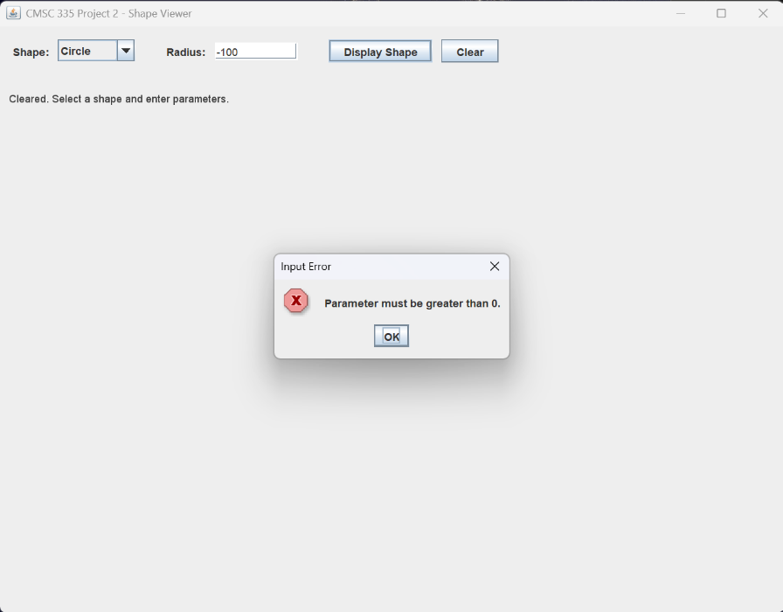
Test # | Description | PASS/FAIL
12 | Non-Numeric Text | PASS
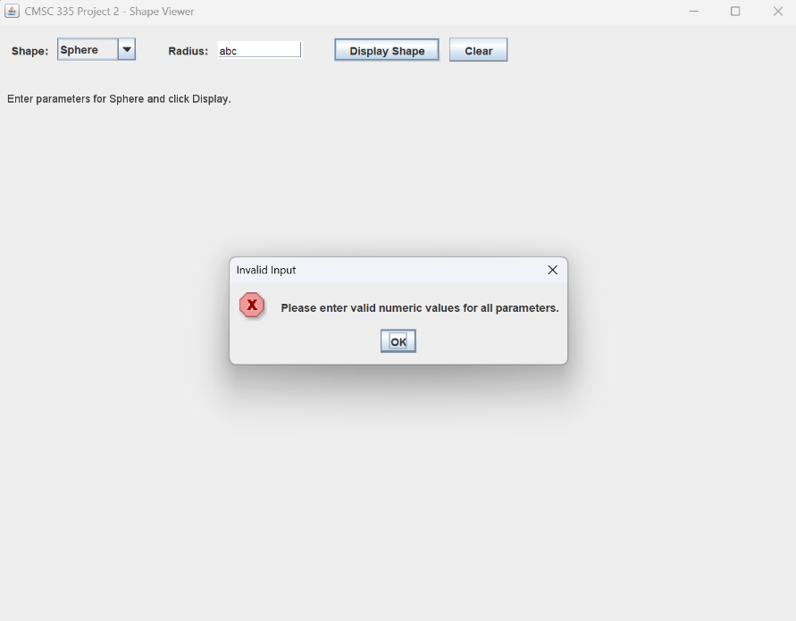
Test # | Description | PASS/FAIL
13 | Clear Button | PASS
